## horizontal line



Manage K8s deployment ec2 using AWS

**─**

# Introduction

* Run an EC2 instance with Minikube.
* Deploy an application.
* The scripts will create resources in: n.virginia

# Launching EC2

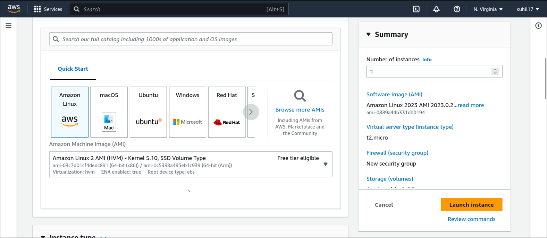

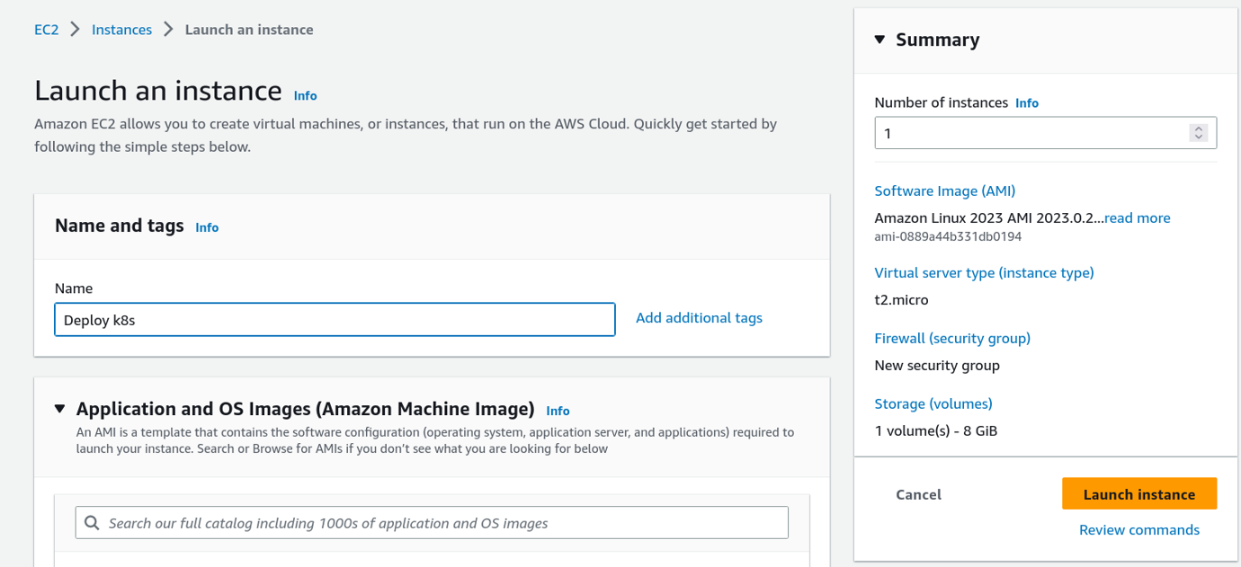

# Starting EC2 with SSH

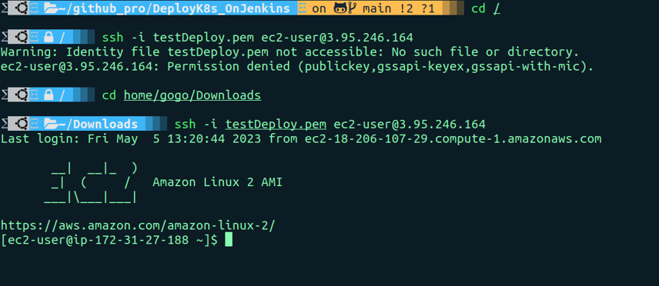

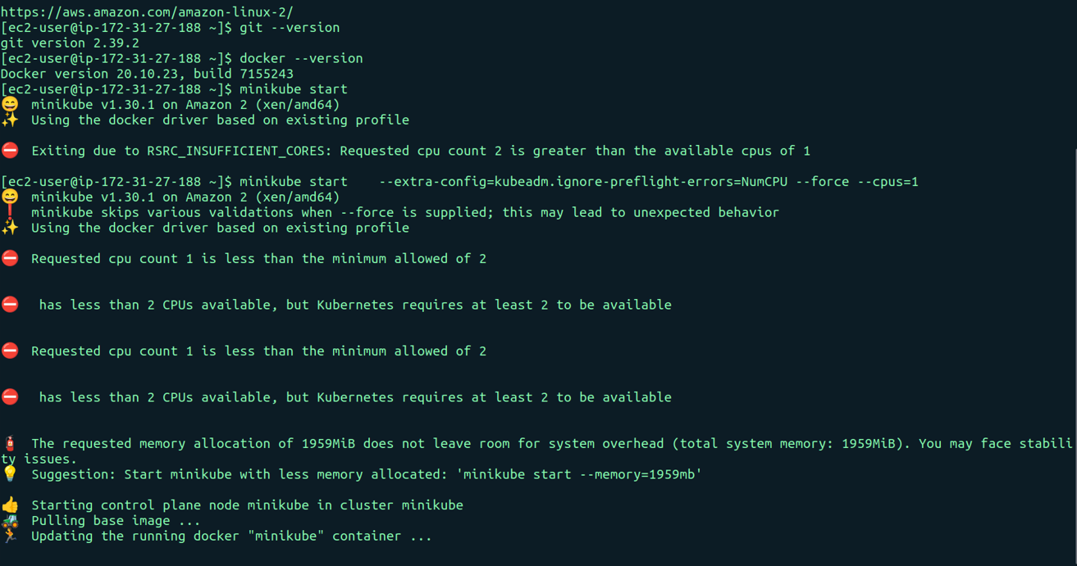

# 

# Deploying files (deployment, service)

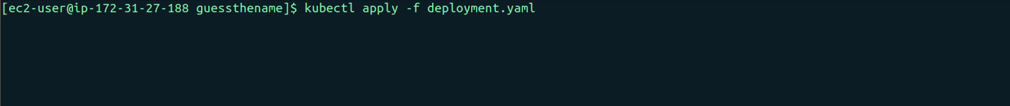

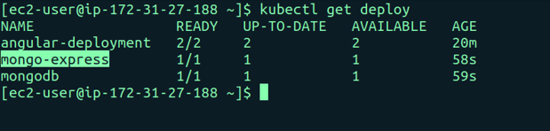



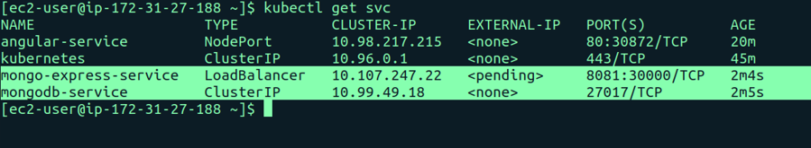

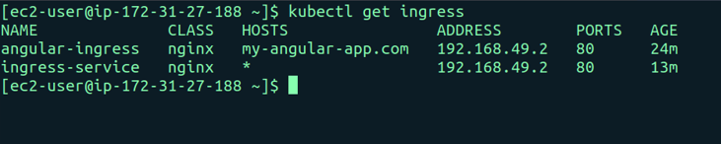

# Testing the deploying

